Login to Connect at
connect.det.wa.edu.au
Connect is an integrated online environment developed by the Department of Education WA for staff, students and parents in public schools.

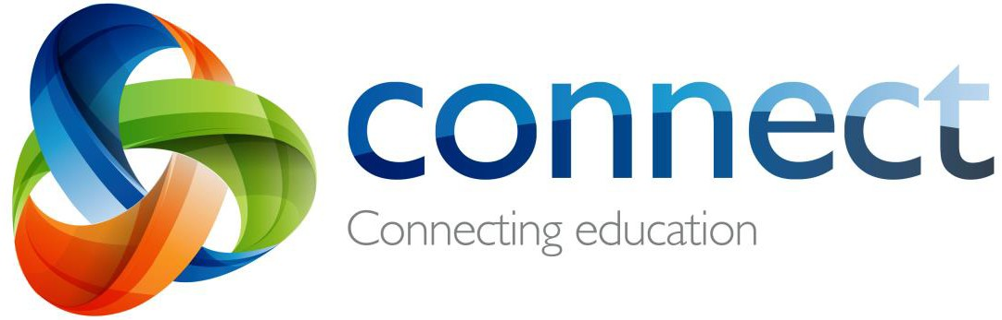

Step by step guide for parents

Contents - Step by step guide for parents

This guide is designed to be read step-by-step. However, due to the number of options available, please use the hyperlinks of this Contents page for quick reference to the specific help needed.

Login
Forgotten user name or password Home page
Classes Selected class On small devices My Children Student Reports
Assessment Outlines Class Notices
My Connect Profile
My Connect Preferences My Connect Notifications Help page
Connect Now app for mobile devices

Connect: Login

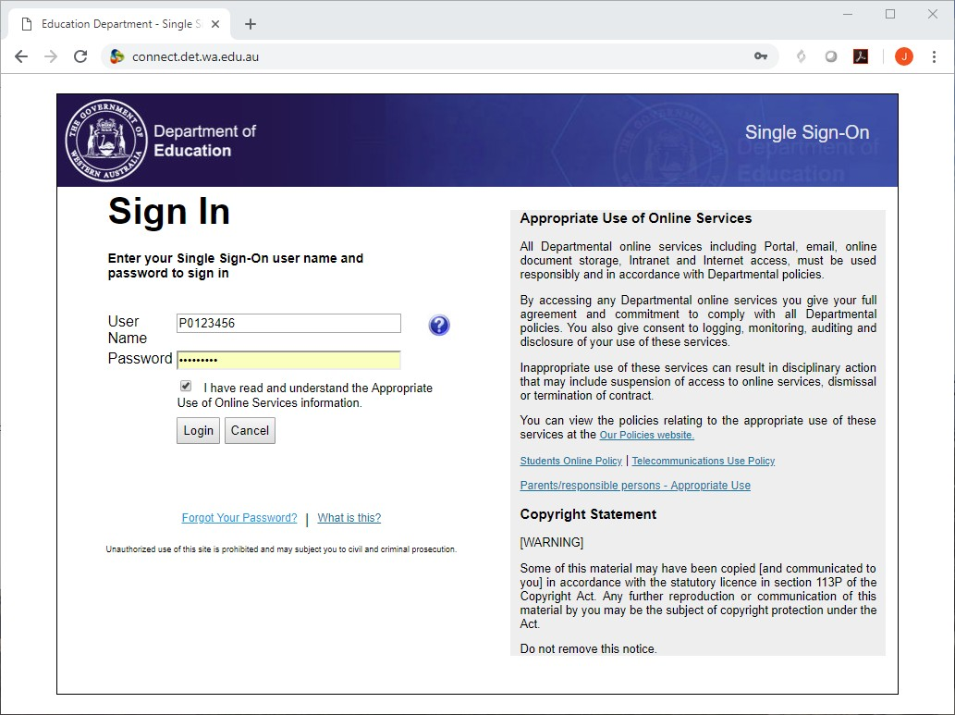Type the Connect website address into your browser as connect.det.wa.edu.au
1
3
2
4
5
1

User name and password
2
Type your user name (P-number) and
password into the text boxes. The
username is comprised of a lowercase “p”
followed by a seven-digit number.
Note: the P Number and password will have been emailed to you by your child’s school.

Parent/Responsible persons
3
Click the Appropriate Use link to access the specific Terms of Use for Connect.

Appropriate Use
4
Tick the ‘I have read …’ box to agree to use the Department’s online services in an appropriate way.

Forgot Password
5
Click the Forgot Your Password link if you can’t remember your login details.

Connect: Forgotten user name or password

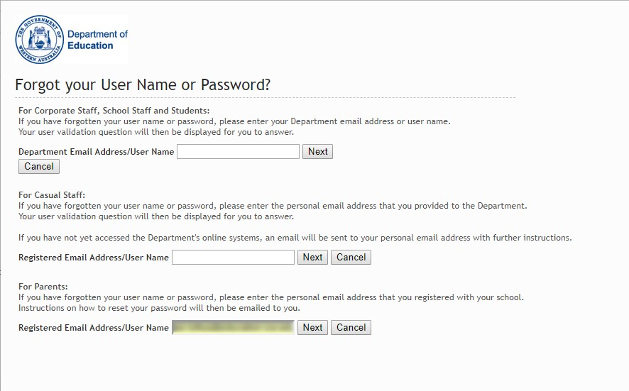Registered email address
1
Type your email address (the one registered at your child’s school) and click Next.

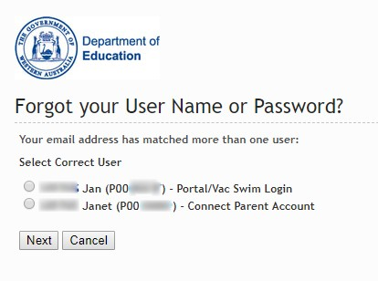1
2

User name and password
2 If you have registered for other Department of Education WA online
services (such as VacSwim) in the past you may have more than one P- number. Select the Connect Parent Account option and click Next.

An email will be sent to your nominated email address allowing you to
reset your password.

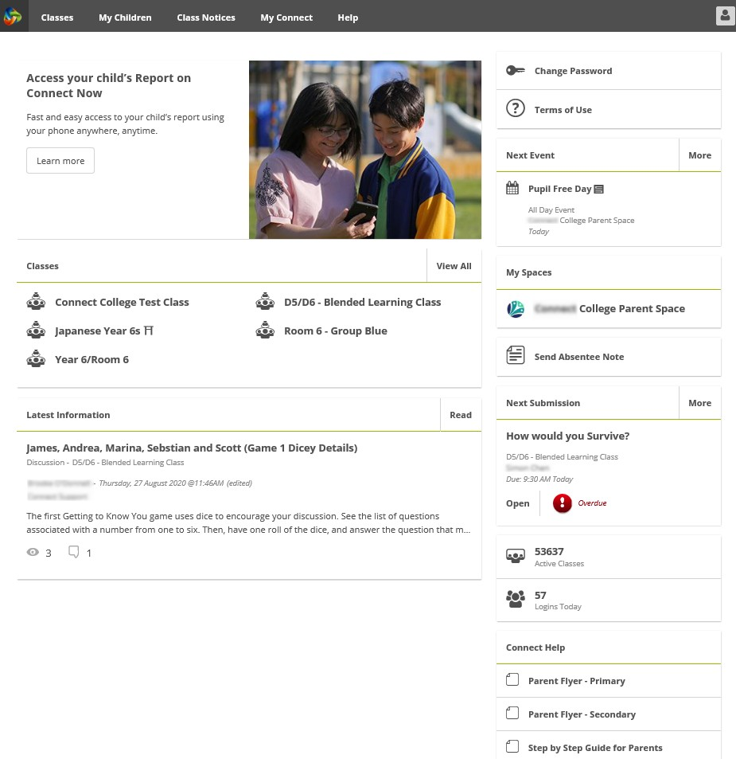Connect: Home Page
1
4
5
6
2
7
8
3
9
10
9
Next Submission
View the next submission due.
additional submissions.
Click the More button to see

Navigation Bar
1
Use the tabs across the top to access different parts of Connect. Return to the home page by clicking on the Connect logo.

All your children’s classes
2
See all the Connect Classes for each of your children in the
Classes box. Click on a Class name to go to that class.

Latest Information
3
See the latest notice or discussion from a class or school space.

Logout
4
Click on the icon at the far right to securely sign out of Connect.

Change Password
5
Click Change Password to reset your password and access other profile options.

Next Event
6
See upcoming school and class calendar events and deadlines for all your children.

School Space
7
Click the name of the School Space to see the latest notices and information from the school.

Send Absentee Note
8
Click to advise the school of an absence if your school has
enabled Absentee Notes.

Connect Help
Quick links to helpful Parent Guides.
10

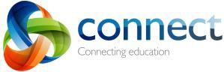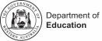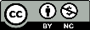

Connect: Classes

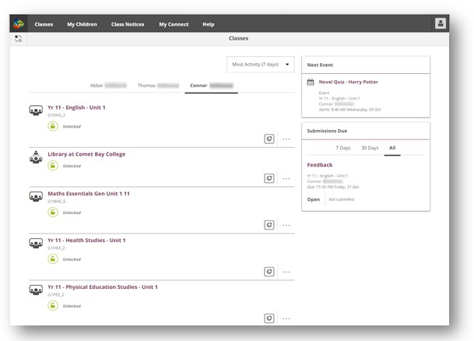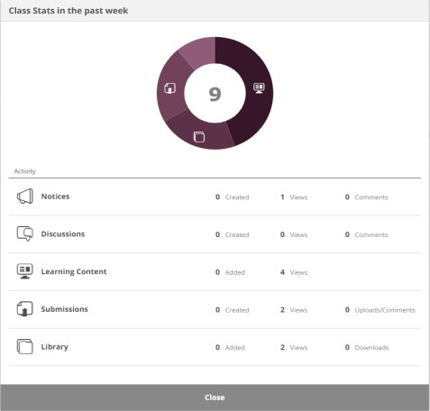1 Classes
1 Click on the Classes tab to access the
Connect classes started for your children.

2 4 2
3

3
5
4
6

5

My Children
Click on the child’s name to see their classes.

Selected Classes
Click on a class name to go into the class.

Next Event
See up to three upcoming events for any of your children from any of their Connect class calendars.

Submissions Due
See any assignments due for any of your children from any of their classes.

Class Stats
6 View statistics on recent activity in each of
your children’s classes.

connect.det.wa.edu.au
Step-by-step guide for parents September 2020

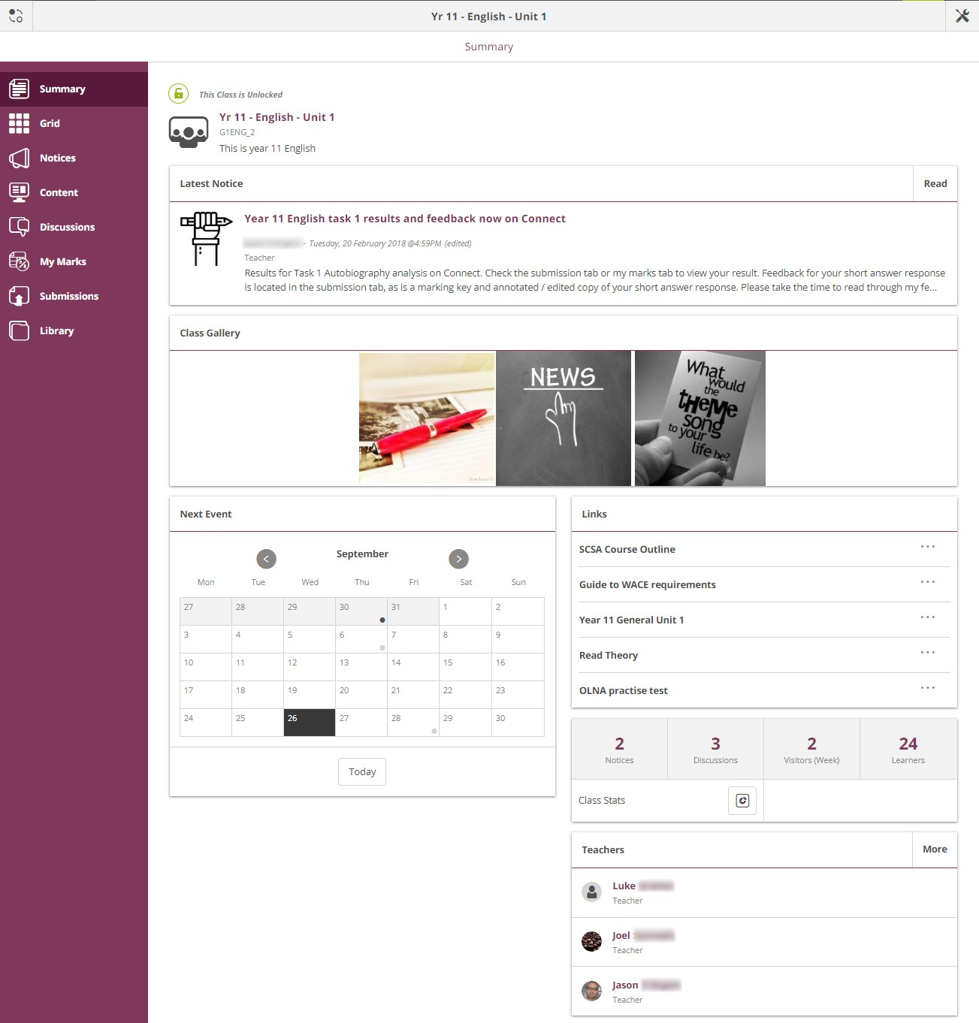Connect: Selected Class
1
2
3
4
5

Class Name
1
The name of the class is displayed at the top.

Switch Classes
2
Click the Switch icon to change to another class.

Class Tools Menu
3
The menu on the left lets you select which area of the class to see.

Class Calendar
4
Days marked with a dot have events entered. Click the day to see the event details.

Email Class Teachers
5
The class teachers are displayed at the bottom of the Summary page. Click on a name to email the teacher.

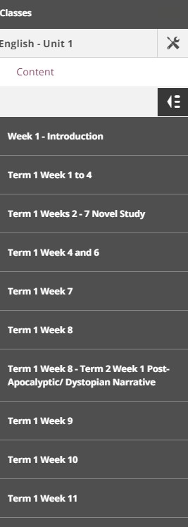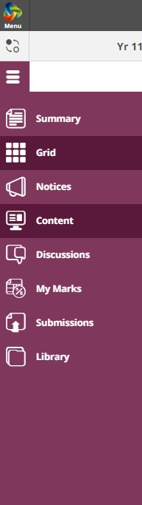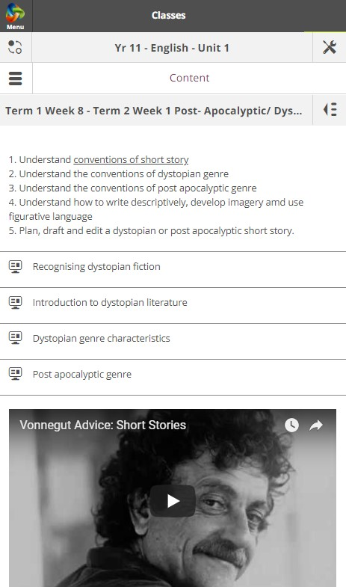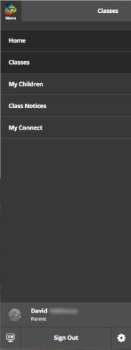Connect: On small devices

Responsive Design
On smaller devices like phones, Connect will change the way it displays information. Menus will move out of the way
1 but can be accessed with just a click if you need them.

Main Menu
1
2 Click the Connect logo to return to the home
page or select another area of Connect to view.

3 Tools Menu
2
Click the Tools Menu icon to access the tools for the School Space or Class you are in.

Additional menus
3
Some areas of a class may have an additional menu to help you navigate through class Content or Discussions. Click the Arrow icon on the right to pop out the menu.

Connect: My Children 1
2
1
My Children
Click the My Children tab to view information about 3
each of your children. 4 4
Switch Children
2
Click the Switch icon to change between your children.
Overview
3
By default you will see the Overview section. Click other 5
sections such as Attendance, Reports or Assessment Outlines to see additional information.
Note: Not all these sections may be visible to all parents.
Schools determine which information is available. 4

Attendance
4
Click in the Attendance box or section to see a 6
week by week view.

Classes
5
Click on a class name to navigate to the class.

Teachers
6
Click on a teacher’s name to send an email to the teacher.

Connect: Student Reports

My Children
1
Click the My Children tab to view information about each of your children.

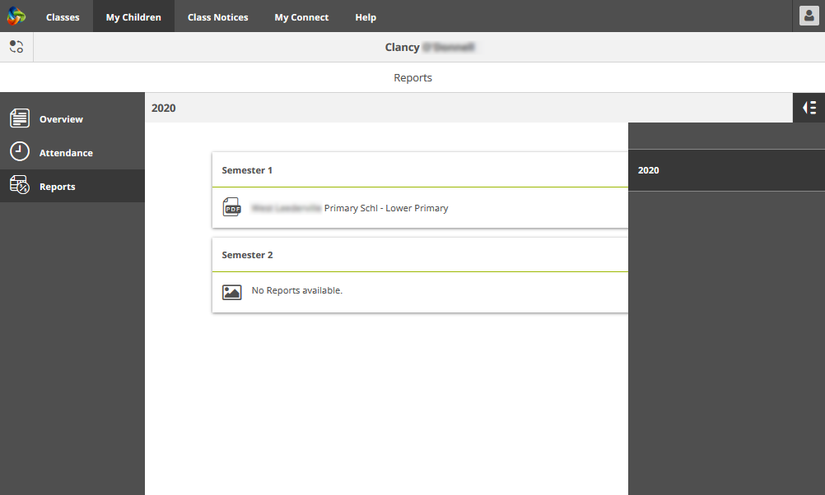Switch Children
1
2
4
3
5
6
2
Click the Switch icon to change between your children.

Reports
3
Click the Reports section to see the
reports for the current year.

Reports from previous years Open the Year Menu to view the years for which reports are available.
4
This may differ from school to school.

Selecting a year
5
Click on a year to view the reports published for that year.
6
Reports by Semester
The reports will be listed by semester. Click on a report to download it. The report can be viewed on screen or sent to a printer.

Connect: Assessment Outlines

1

My Children
1 Click the My Children tab to view information about each
of your children.

Switch Children
2 2 Click the Switch icon to change between your children.

Assessment Outlines
3 Click the Assessment Outline section to open the
Assessment Outlines for the current year.

3

4 Total Percent and Grade
4
Overall achievement will be displayed as a percentage. If the end of semester report has been finalised, a grade
5 may also be displayed.

6

A B D

C

Expand the Assessment Outline
Click the expand/collapse icon to see more details about an Assessment Outline.
5

Comparison Graph
6
Beneath the overall achievement and each task, a small
graph displays the range of achievement across the class.
A B C D
The line represents the top and bottom marks.

A The box demonstrates the majority of students.
The vertical line is the average mark.

The dot represents the achievement of your own child.

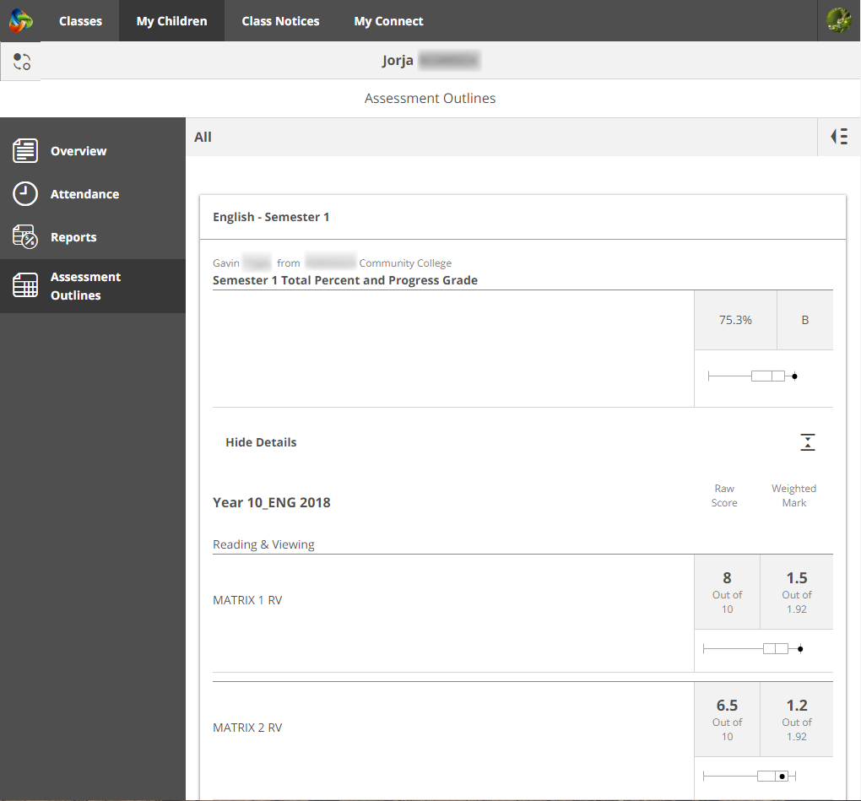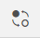connect.det.wa.edu.au
Step-by-step guide for parents September 2020

Connect: Class Notices

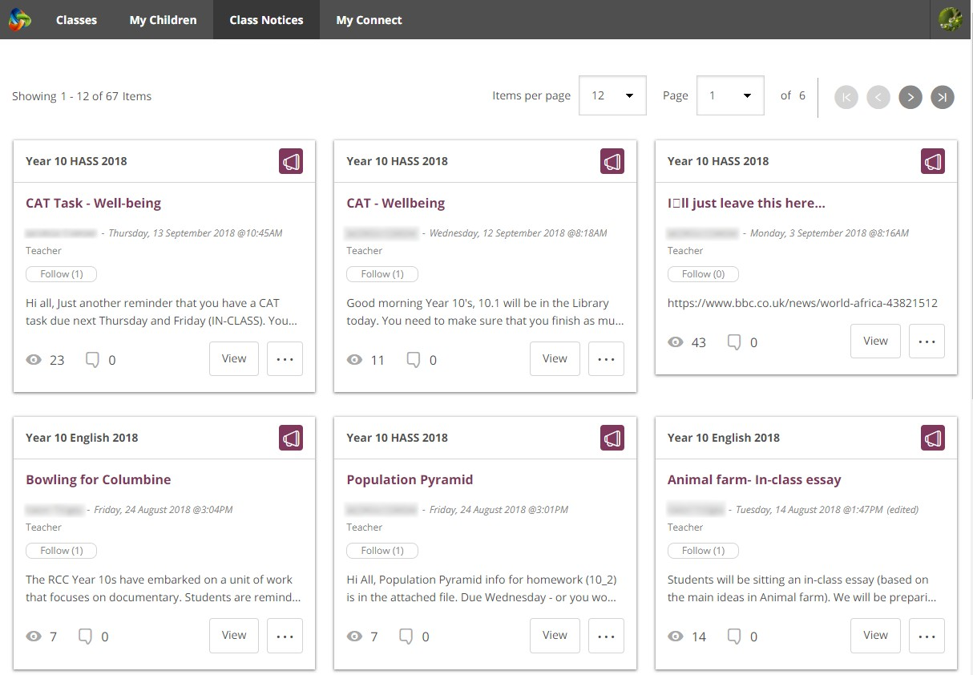Class Notices
1
2
3
4
5
1
Click the Class Notices tab to view notices
from all your children’s classes with the most recent at the top.

Number of notices per page
2
Click the down arrow to select how many notices to display on a page.

Page number
3
Click the down arrow to select which page to view.

Forward and back
4
Scroll through the pages using the forward and

back arrows.
5

Open a notice
Click on the title of a notice to open it.

Connect: My Connect Profile

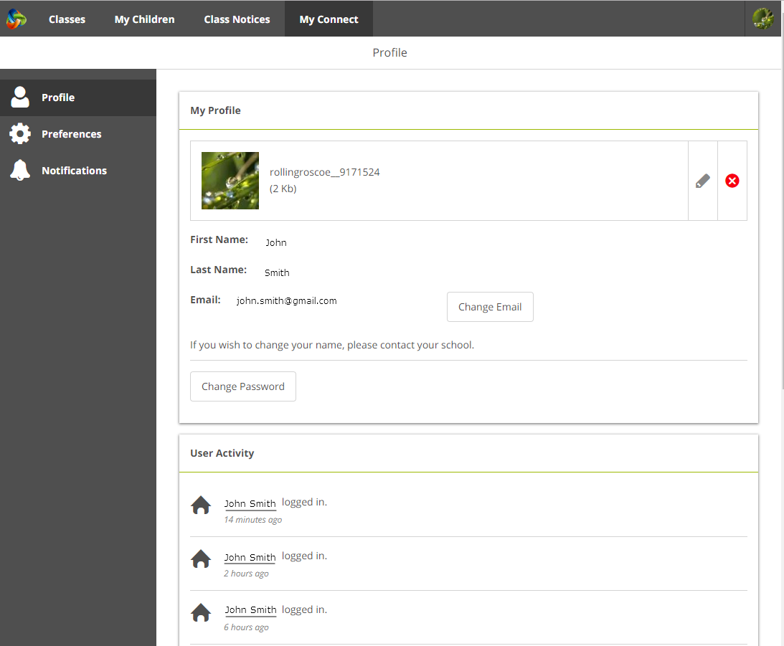My Connect
1
1
2
2
3
4
3
5
6
4
5
6
Click the My Connect tab to manage your profile, password, preferences and notification settings.

Manage your profile
Click the Profile section to select an avatar, change your password and send a notification to the school if you change your email address.

Select, edit or remove an image
Click the Add Avatar button to select from a range of images. Use the edit pencil to change the image you have selected or click the cross to delete it.

Change your email address
Notify the school when you change your email address.
The school will receive a notification to update their system.

Change your password
Click the Change Password button to reset your password.

View your recent activity
See a list of your recent activity in Connect.

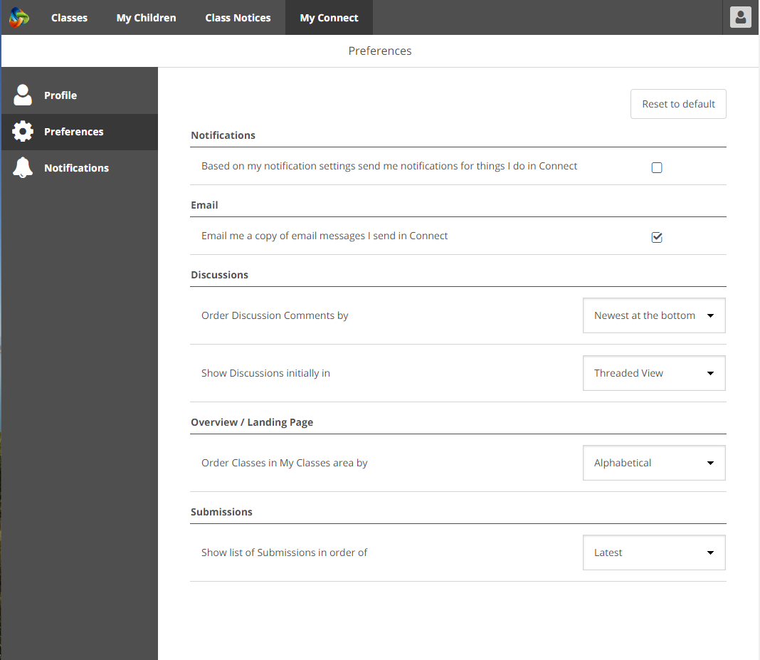Connect: My Connect Preferences

My Connect 1
1
Click the My Connect tab to manage your profile, password, preferences and notification settings.

Preferences
2
Click the Preferences section to choose how 2
Connect displays information for you. 3

Notifications 4
3
Tick this box if you would like emails to be sent to you when you add a comment to a Notice.

5
4

Email
Tick this box if you would like a copy of any emails you send to a teacher to be sent to your email inbox.

6

Discussion Preferences
5
Click the down arrows to select how class discussions are 7
ordered and displayed.

Order Classes
6
Click the down arrow to select the order in which the classes are displayed on the Connect home page.
7

Submissions
Click the down arrow to select the order in which class submissions are displayed in Connect classes.

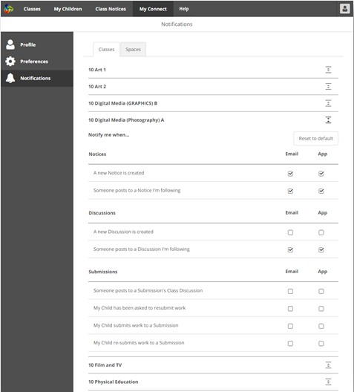
Connect: My Connect Notifications
1
1
2
2
3
3
4
5
4
5
6
6

My Connect
Click the My Connect tab to manage your profile, password, preferences and notification settings.

Manage your notifications
Click the Notifications section to select how information is sent to you from specific classes and school spaces.

Classes or Spaces
Click either the Classes or Spaces tab to select which notifications you wish to modify.

Expand Class Notifications options
Click the expand/collapse icon for each class or space to see the notifications options.
Email or App
By default all notifications will come to you via the email address you have registered with your school. If you have downloaded the free Connect Now app (see Connect Now page) you can elect to receive push notifications on your mobile phone instead of or in addition to the email.
Note: You won’t see the App option until you have logged into the
Connect Now app with your parent user name and password.

Submission Notifications
Tick the boxes to receive notifications when your child submits work to a class submission.

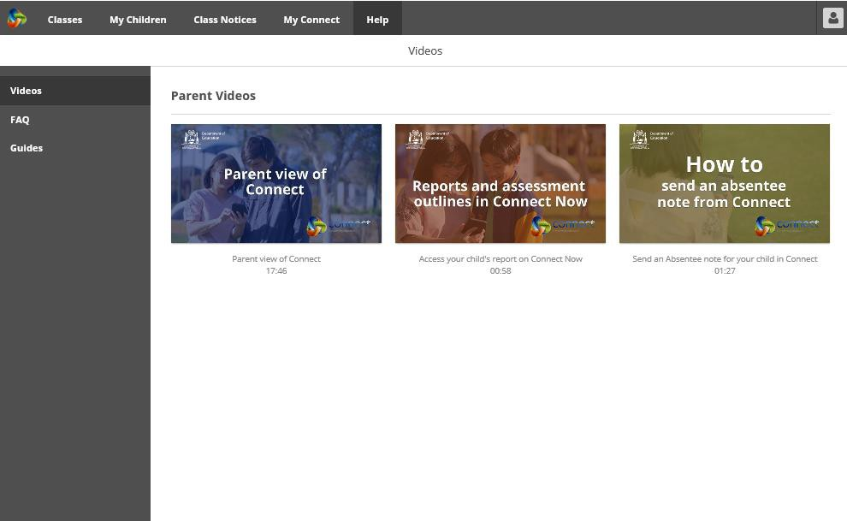Parent Videos to provide a virtual tour and demonstrate commonly used features of Connect.
Connect: Help Page
1
1
2
2
3
3

FAQ
Browse or keyword search for advice and answers to commonly asked questions.

Guides
Click on Quick or Step-by-Step Guides to read further about the features of Connect and help you to navigate through the space.
4

5

Connect: Connect Now app for mobile devices

Connect Now
1
Receive Connect notifications on your mobile
device. Download the Connect Now app 2 4
from the Apple App Store or Google Play.

Push Notifications 3
2
You can elect to have notices appear as Push Notifications on your mobile device home screen.

Login 1
3
Use your Connect P-number and Password
to login to Connect Now.

Opening Notifications
4
Tap the push notification or open the app to 6
read notices.

Notices 5
5
Tap a notice to open it and see more details including images and attachments.

Connect Now Options
6
Click the Connect Logo to access the Stream, the My Children list and built-in Help.

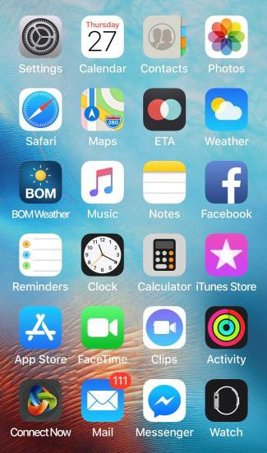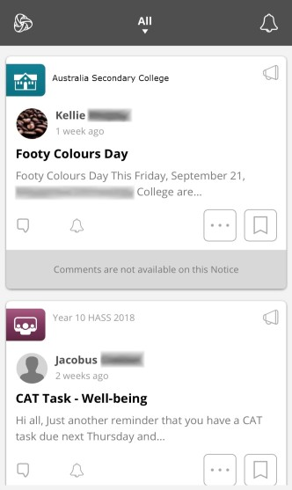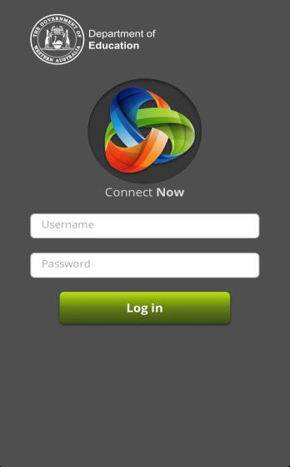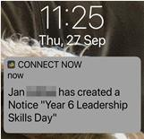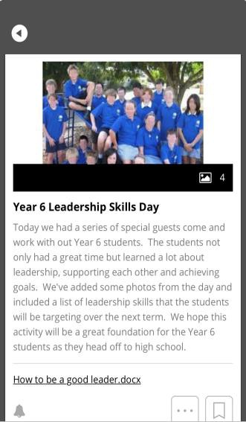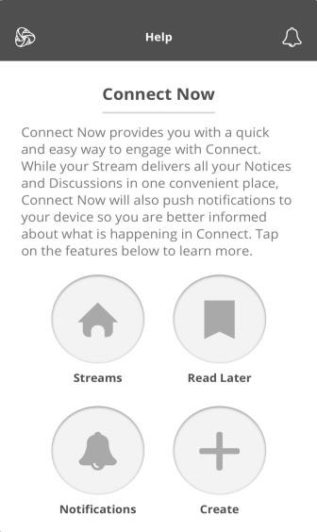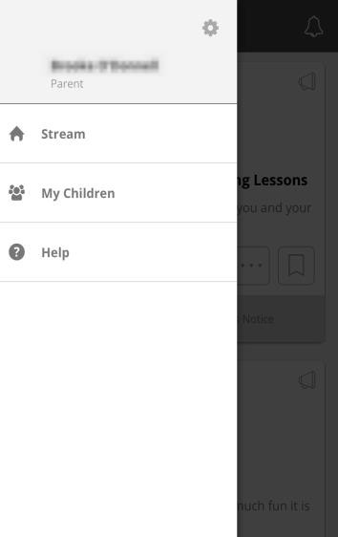connect.det.wa.edu.au

Step-by-step guide for parents September 2020

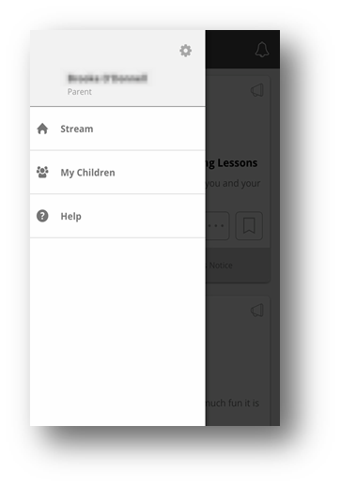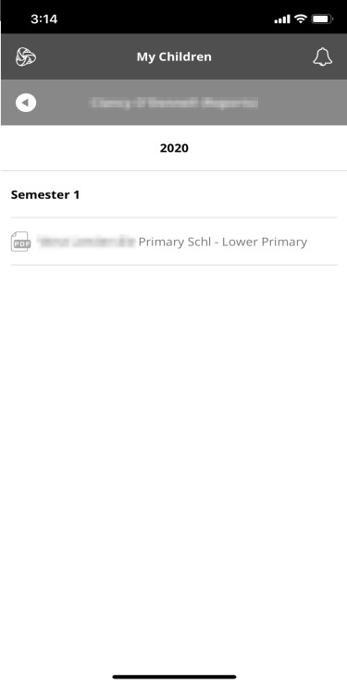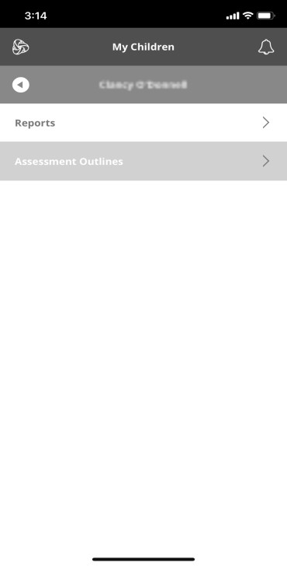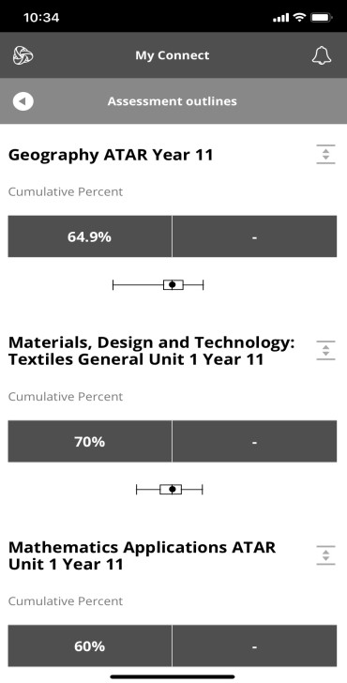Connect: Reports and Assessment Outlines on the Connect Now app

My Children 7
7
After clicking select My Children to view
your children from Connect Now. 8

Reports and Assessment Outlines
8
After choosing your child from My Children, you will be able to see Reports and Assessment Outlines for your child.
Note: Schools decide whether to turn on these features.

Reports
9
If you select Reports, you will be able to view and download the report on your hand held device.

Assessment Outlines
10
View the Percent and Comparison Graph 10
showing the range of achievement across the 9
class.

connect.det.wa.edu.au

