Login to Connect at
connect.det.wa.edu.au
Your school will provide you with a secure user name (also known as a P number) and a password. Log on to communicate easily with teachers, stay informed about
school activities and events, securely access your child’s learning assessments and feedback and engage in your child’s learning anytime, anywhere and on any device.

Quick guide for parents (Primary)

Connect: Home Page
All information about your children is accessible from the
landing page of Connect. A

Change Password
A
Manage your password and notify the school if C
you change your email address.

Classes
B
Select your child’s name to see all the Connect
D
classes available for that child. B
E
C

School Space
Find the latest notices and information from your school.

Send Absentee Note
D
Notify the school of the reason for your child’s F
absence and attach a medical certificate.

Next Event
E
Stay up to date with school and class events and deadlines.

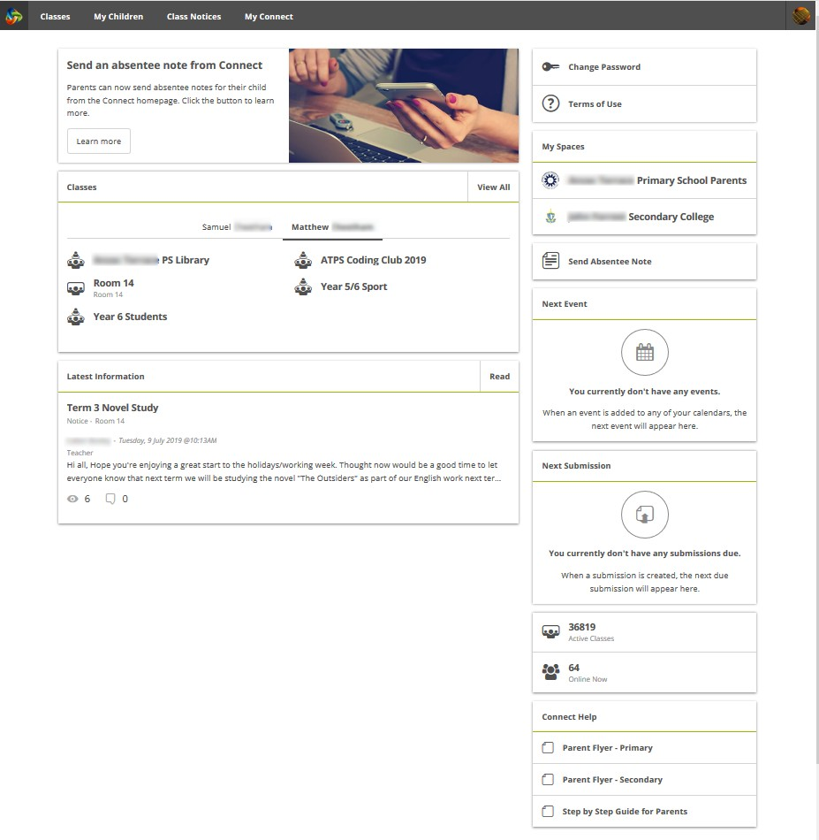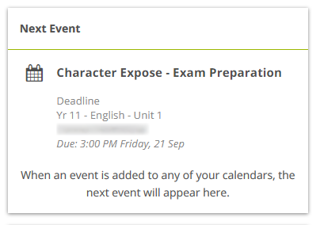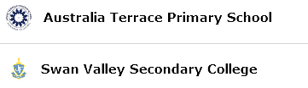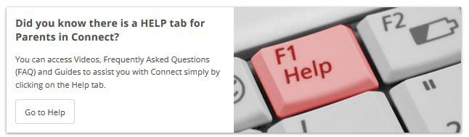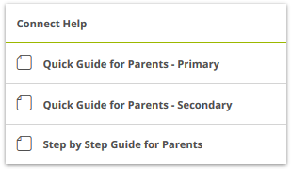Next Submission
F
View homework and assignments due in all your children’s classes.

Help
G
Your link to both quick and detailed Guides to help you to use Connect.

connect.det.wa.edu.au

G

Quick guide for parents (Primary) Sept 2020

Connect: Navigation Toolbar

H I J K L

Classes
H
View all classes for all children.

My Children
I
View attendance, performance and report data about your children.

Class Notices
J
View all notices from all your children’s classes.

My Connect
K
Reset your password, change your preferences and manage your notifications using My Connect.

Help
L
Your link to a range of Videos, FAQs and
Guides to help you to use Connect.

connect.det.wa.edu.au
Quick guide for parents (Primary) Sept 2020

Connect: My Children
In My Children, you can see each child’s classes and teachers (on the right side of the Overview screen). It is important to note that schools determine which information is available and not all sections will be visible to all parents.

Overview
M View each of your children’s Connect
Classes to see your child’s logins and activities related to notices, calendar events, learning activities and submissions.

Attendance
Click through each week of the term to see a detailed attendance record. View trends in your child’s attendance with a week by week record.
N

Reports
Open your child’s semester reports to download or print.
O

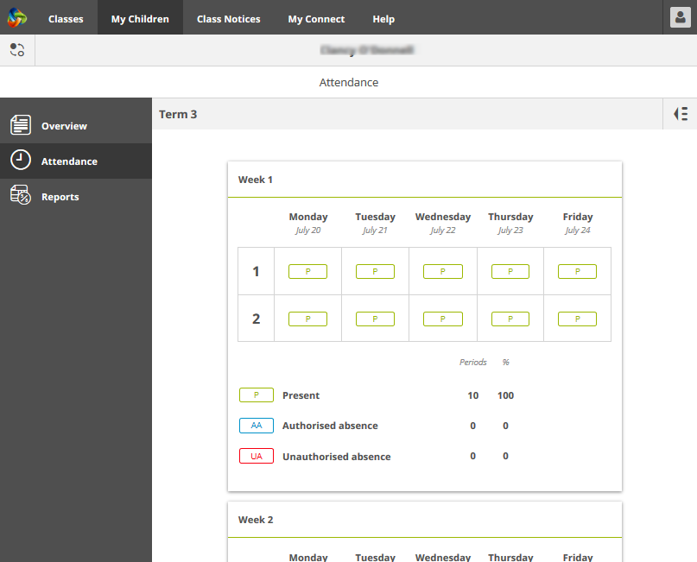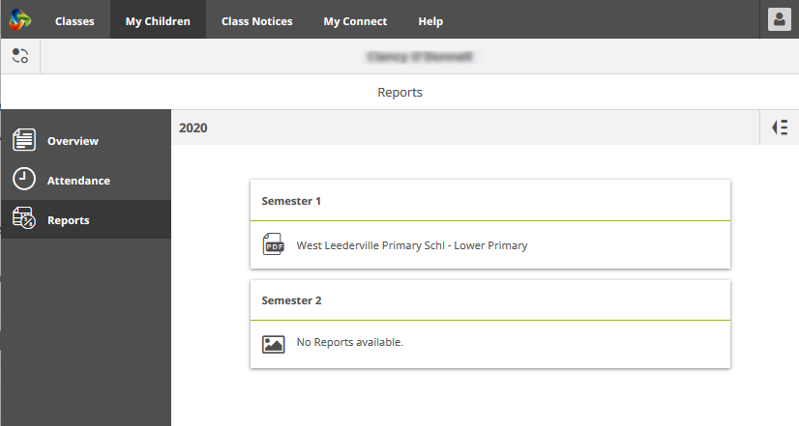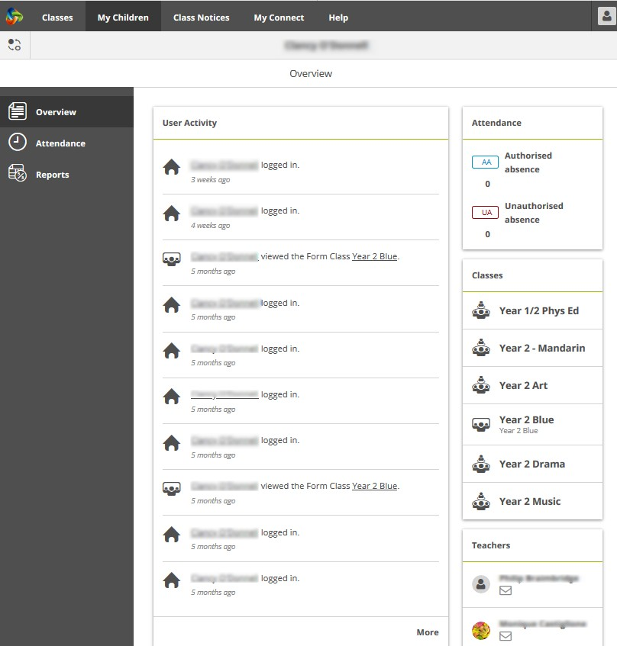

M
N
O

Note: Schools decide whether some of these features are available to parents.

Connect: Responsive Screens and Easy Navigation
Connect is responsive to your viewing screen. Menus will move out of your way to improve your view on a phone or tablet.

Switch Between Children
P
See information about each of your children – regardless of school.
Use the ‘Quick Switch’ button
to change between your children.

Expand the menu
Click on the icon to expand the menu and easily switch between Overview, Attendance and Reports.
Q
View past Attendance and Reports Click on the icon from the Attendance screen to view attendance
of previous weeks. From the Reports screen, click on the and view Reports from previous years.
R

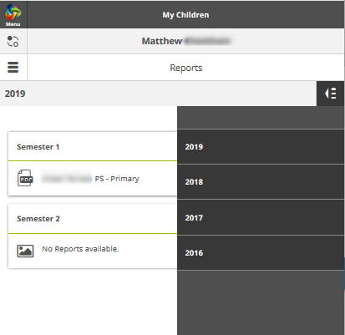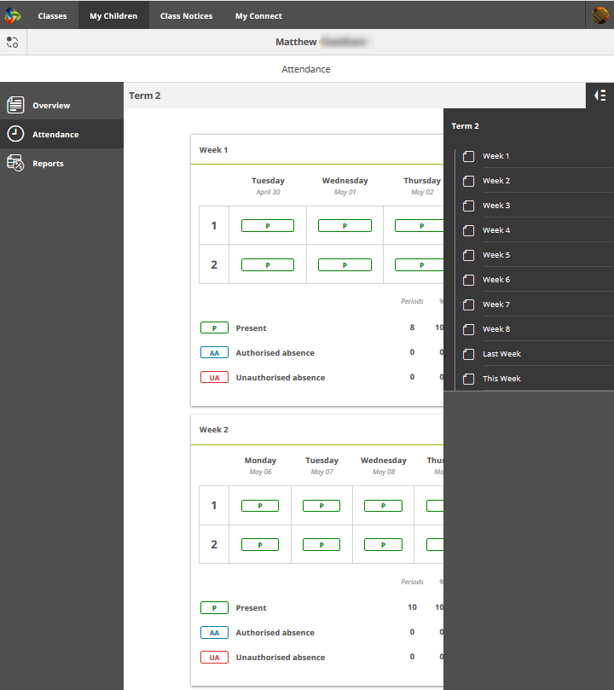

P Q R
Q
R

